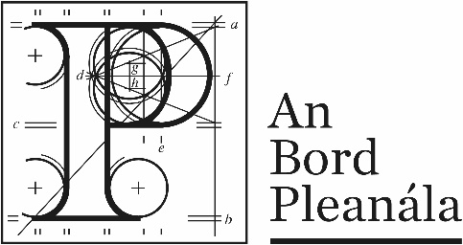 | Memorandum
 | ABP-318573-23
To: | Sarah Lynch, Assistant Director of Planning
From: | Rachel Gleave O’Connor, Senior Planning Inspector
Re: | Notice of significant further information for application under s.51(4A) of the Roads Act as amended, ref. ABP-318573-23
Date: | 08 January 2025
In relation to the above application and following a review of the further information received, I am recommending that the Board publish notice of further information. Please consider the recommendation and let me know if you approve. If so, I will direct the preparation of the request through the section.

Overview
An application has been made by Meath County Council under the provisions of section 51 of the Roads Act 1993, as amended, for the development of a proposed road development comprising of the N2 Slane By-Pass and Public Realm Enhancement Scheme in the townlands of Slane, County Meath.
The Board requested further information from the applicant on 8th October 2024. The applicant requested an extension to the 16th December to respond to this request which was agreed. On the 16th December further information was received. Following a review of this further information, it is recommended by the Inspector that the information submitted in response to the request contains significant additional information.

Information received
The following document was submitted by the applicant in response to the request for further information: ‘Slane Bypass & Public Realm Enhancement Scheme, Additional Information Response Document December 2024 ABP-318573’.
The 237 page report provides a response to each of the further information request points made, referenced 1 to 3(a-i). It also includes associated tables, figures and appendices to support the information provided. Information within the report supplements the findings of the EIAR and NIS documents received as part of the original submission, in the determination of the potential effects of the proposed development.

Recommendation
It is recommended that notice be published and circulated to all interested parties that significant additional information has been received in relation to the effects of the proposed development.
In accordance with Section 51(4A) of the Roads Act 1993 (as amended) the notice should specify where the additional information will be available, for inspection and that submissions or observations in relation to the additional information may be made in writing for a period of 4 weeks from the date of notification.

__________________
Rachel Gleave O’Connor
Inspectorate
8th January 2025

